

**MONTCLAIR STATE UNIVERSITY**

CSIT555_04FA23

Submission of Final Project by

**TEAM: REBOOTERS**

TEAM MEMBERS:

Varshini Reddymalle

Kavya Sri Javvadi

Tejaswini Meka

Naveen Vanamamala

Table of Contents

INTRODUCTION 3

Source code of Python, SQL, HTML, Javascript, and CSS 3

PYTHON CODE 3

HTML and JavaScript 5

HTML CODE 10

CSS CODE 10

SQL SCHEMA 11

UI Interface 12

USE CASE 1: CREATE 13

USE CASE 2: READ 14

USE Case 3: UPDATE 14

USE CASE 4: DELETE 16

USE CASE 5: TAX calculation 17

GitHub URL: 18

YouTube URL 18

# INTRODUCTION

In this project, we as a team of 4 members have divided the tasks and achieved the required output using the tech stack – Python, Flask, JavaScript, HTML, CSS. In this document, we have specified all the UI screenshots, Backend Database SQL Schema and DB connection, and the controllers, endpoints, API’s. We have clearly depicted the use cases of CRUD operations (CREATE, READ, UPDATE AND DELETE)

**Overview:**

This project aims to develop a comprehensive web-based application for Limited Liability Companies (LLCs) to efficiently track, calculate, and manage their tax payments to the New Jersey State tax office. The system will facilitate the recording of payments, display payment history, and allow for easy insertion of values into the database.

**Key Features:**

**User Authentication:**

Implement a secure login system to authenticate users and ensure that only authorized individuals have access to the tax payment tracking system.

**Dashboard:**

Provide a user-friendly dashboard displaying a summary of the LLC's tax payment history, upcoming payment due dates, and any outstanding payments.

**Database Management:**

Create a robust database system to store and manage tax payment information. This should include tables for company details, payment history, and user accounts.

**Tax Calculation:**

Implement a tax calculation module that considers the breakdown of payments due four times a year: April 15, June 15, September 15, and January 15 of the following year.

**Data Entry:**

Develop a web interface allowing users to input tax payment details, including company name, amount, payment date, and status (paid/unpaid). Users should be able to update the payment status as well.

**Payment Status Tracking:**

Clearly display the payment status for each transaction, indicating whether it is paid or unpaid. Highlight upcoming due dates to alert users.

**Notifications:**

Implement a notification system to remind users of upcoming payment deadlines, ensuring timely submissions.

**Reporting:**

Create a reporting module that allows users to generate comprehensive reports on their tax payment history, aiding in financial planning and analysis.

**Data Validation:**

Implement robust validation checks to ensure that accurate and valid data is entered into the system, reducing the risk of errors.

**Security Measures:**

Incorporate security measures, including encryption, to protect sensitive financial data and ensure compliance with data protection regulations.

**Responsive Design:**

Develop a responsive and intuitive user interface that works seamlessly across various devices, making it accessible to users on desktops, tablets, and smartphones.

# Source code of Python, SQL, HTML, Javascript, and CSS

Backend code connecting database, SQL schema, controllers, and endpoints, APIs:

### PYTHON CODE

* Flask route for Home page and “Save” action

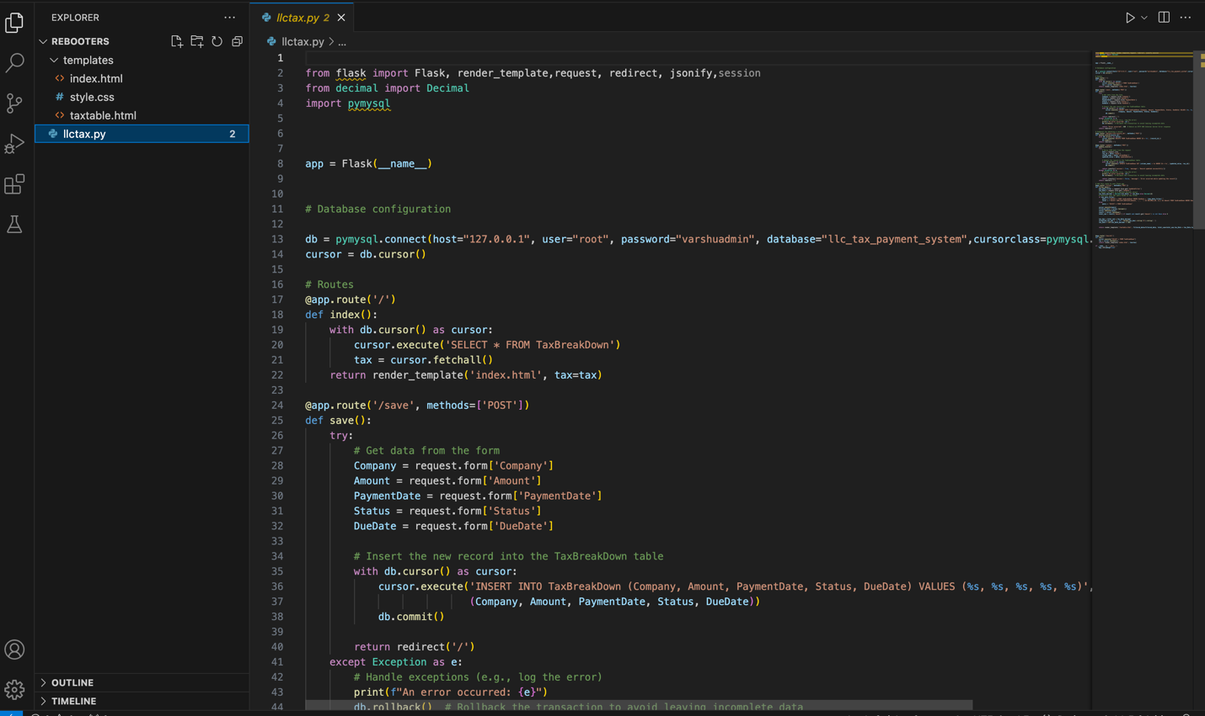

* Flask route for “Delete” and “Update” action

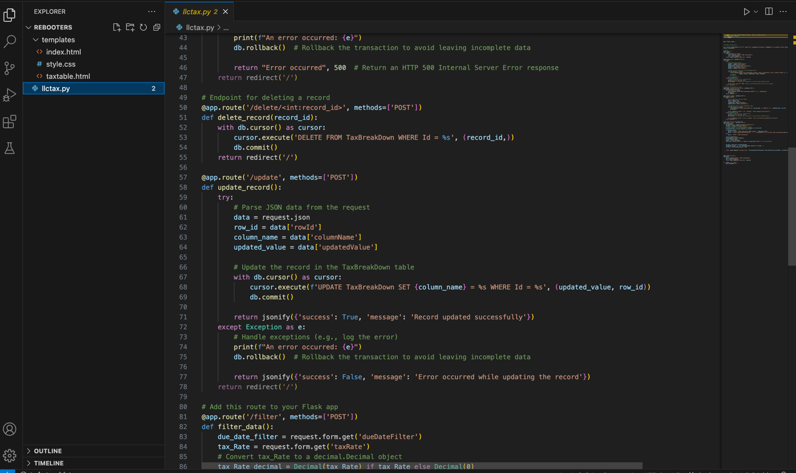

* Flask route for “Filter” action

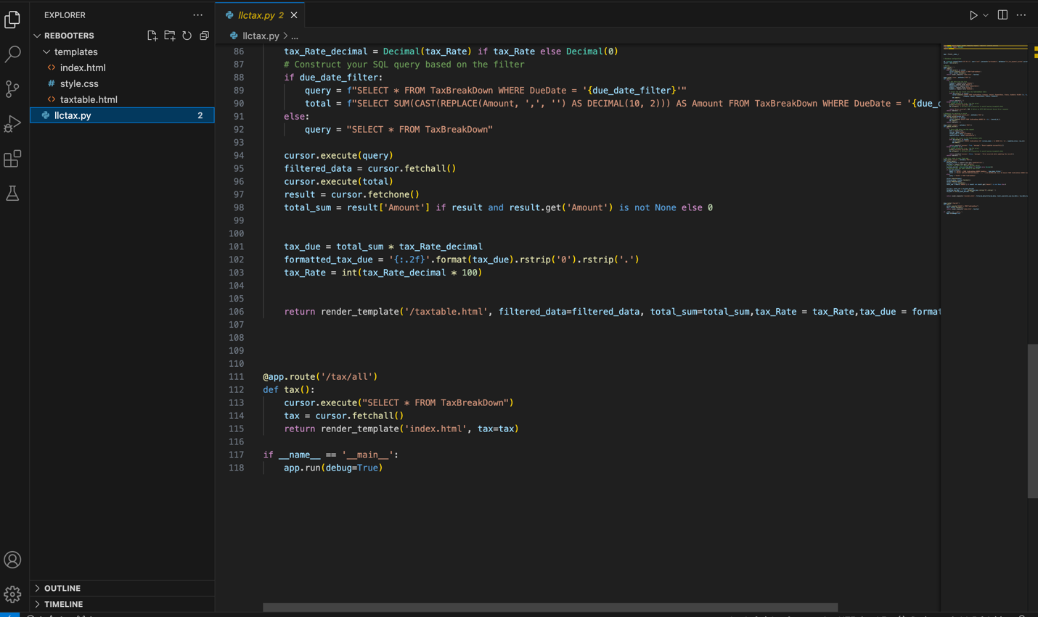

### HTML and JavaScript

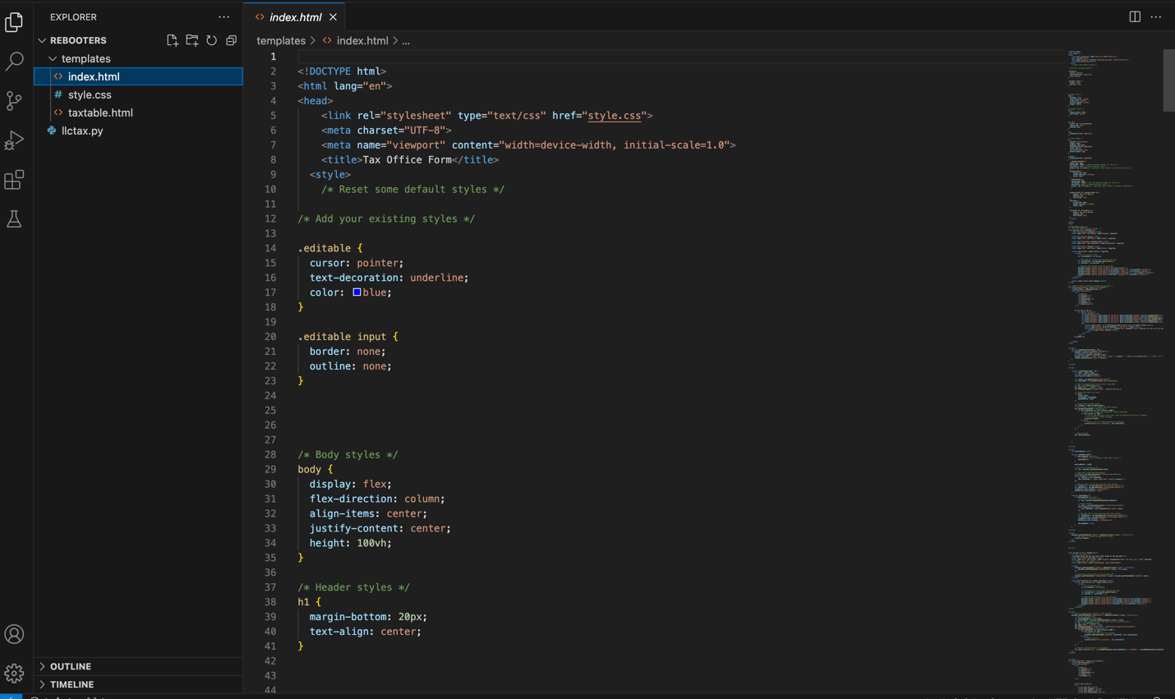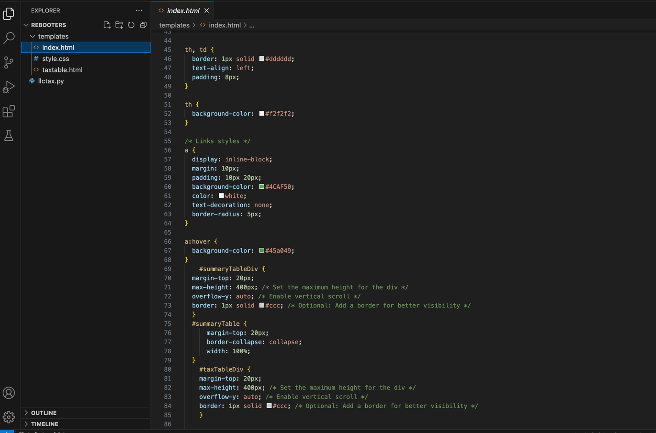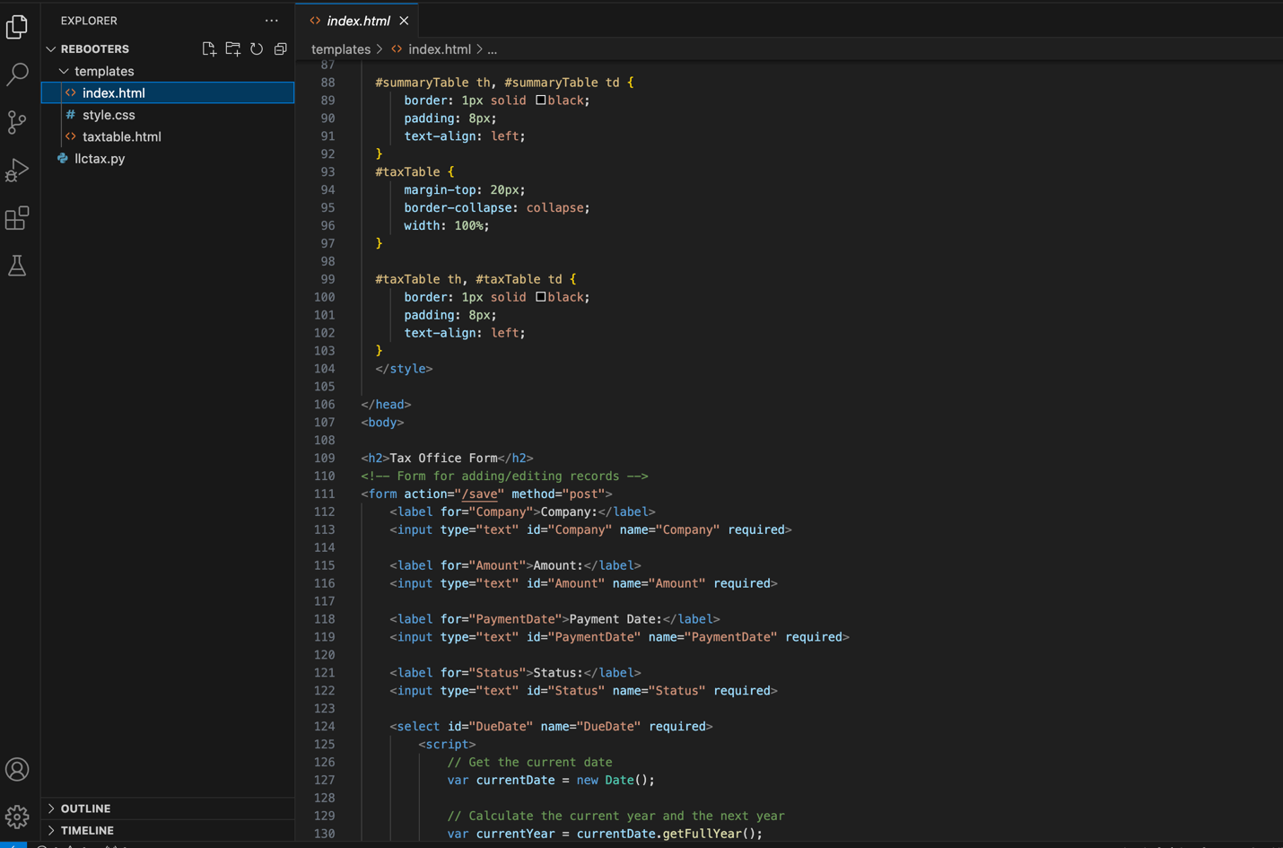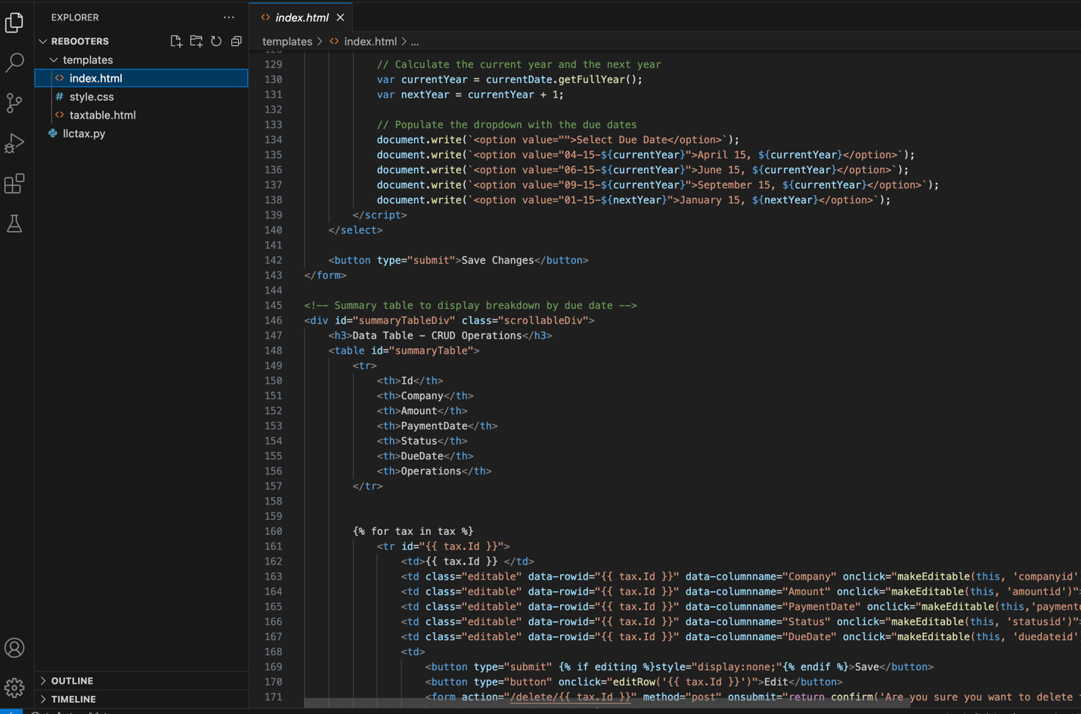

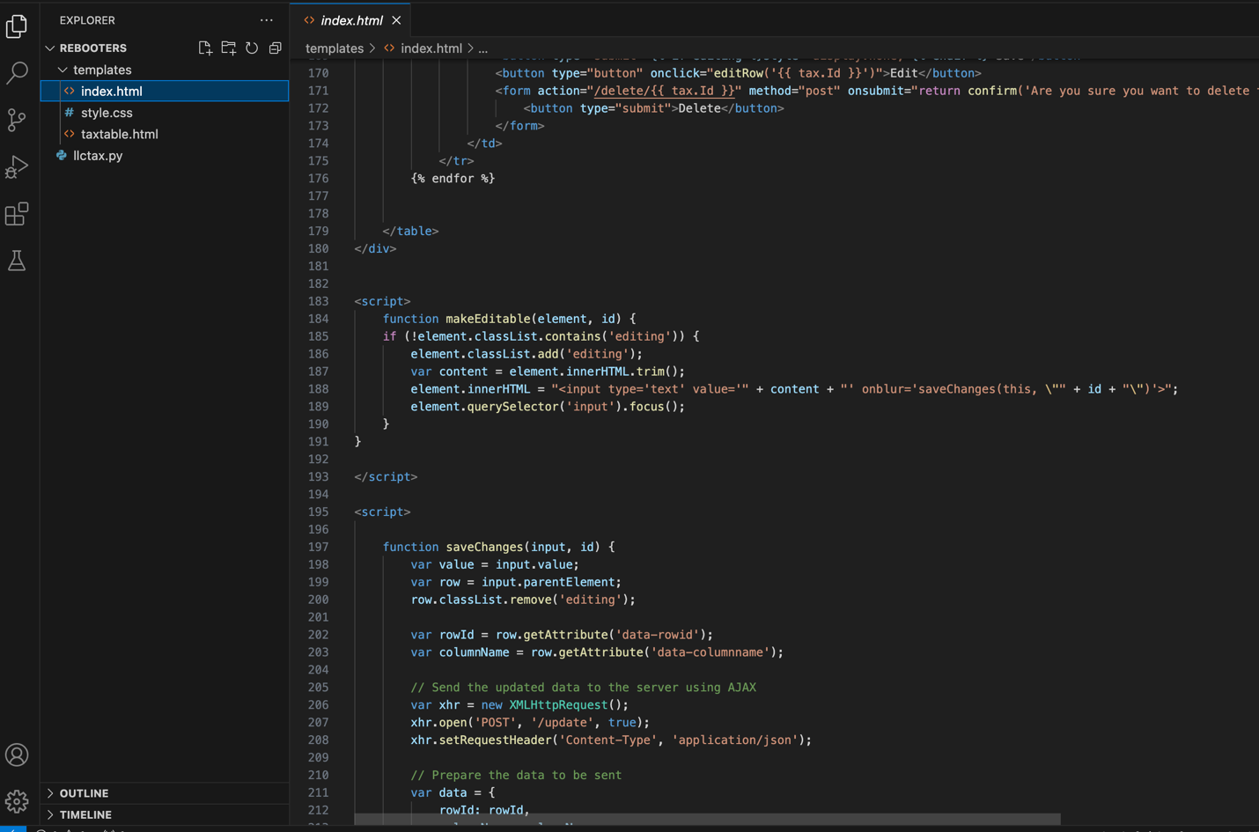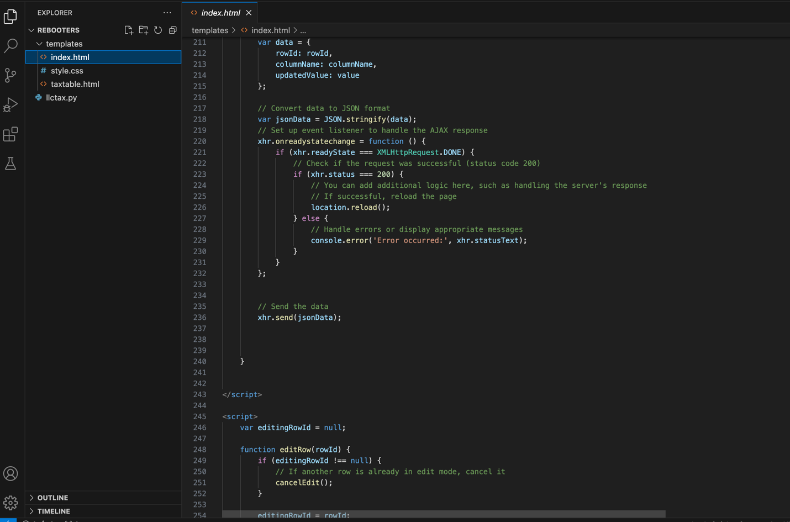 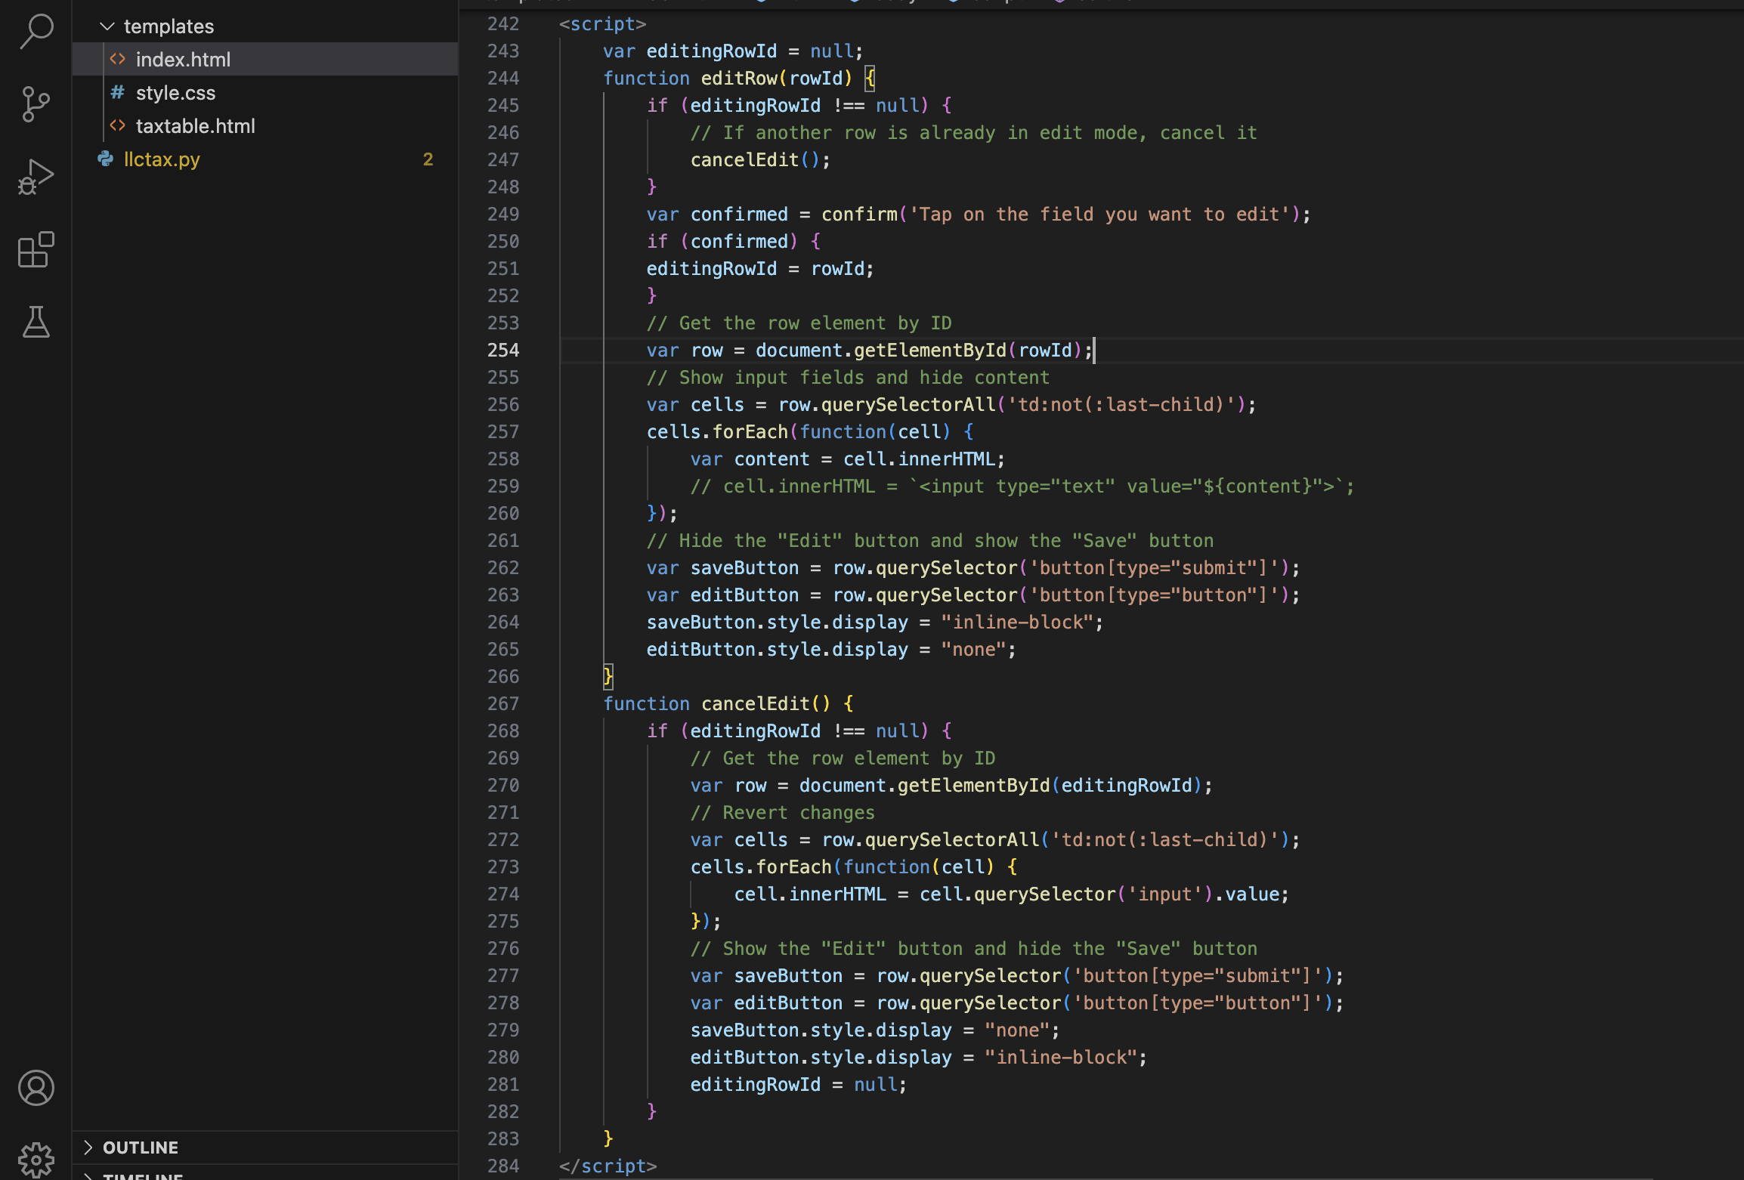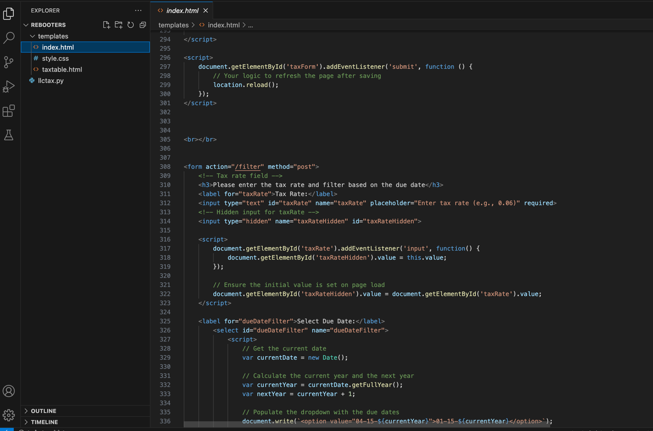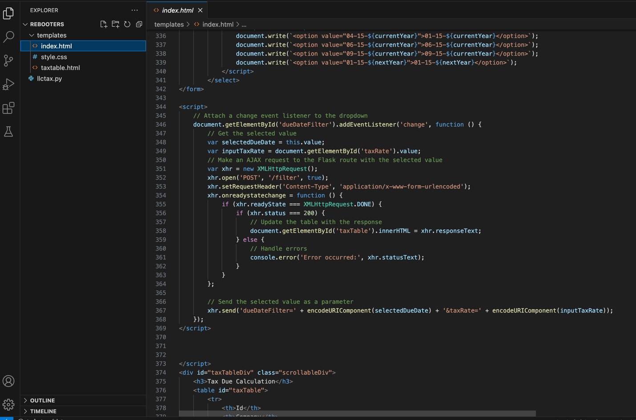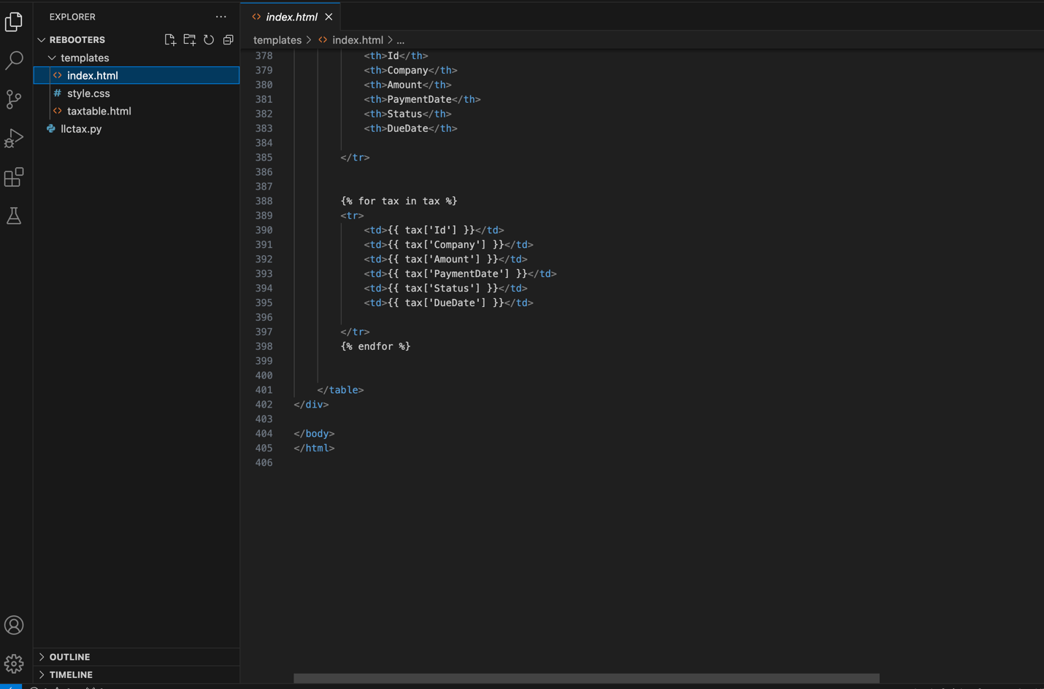

### HTML CODE

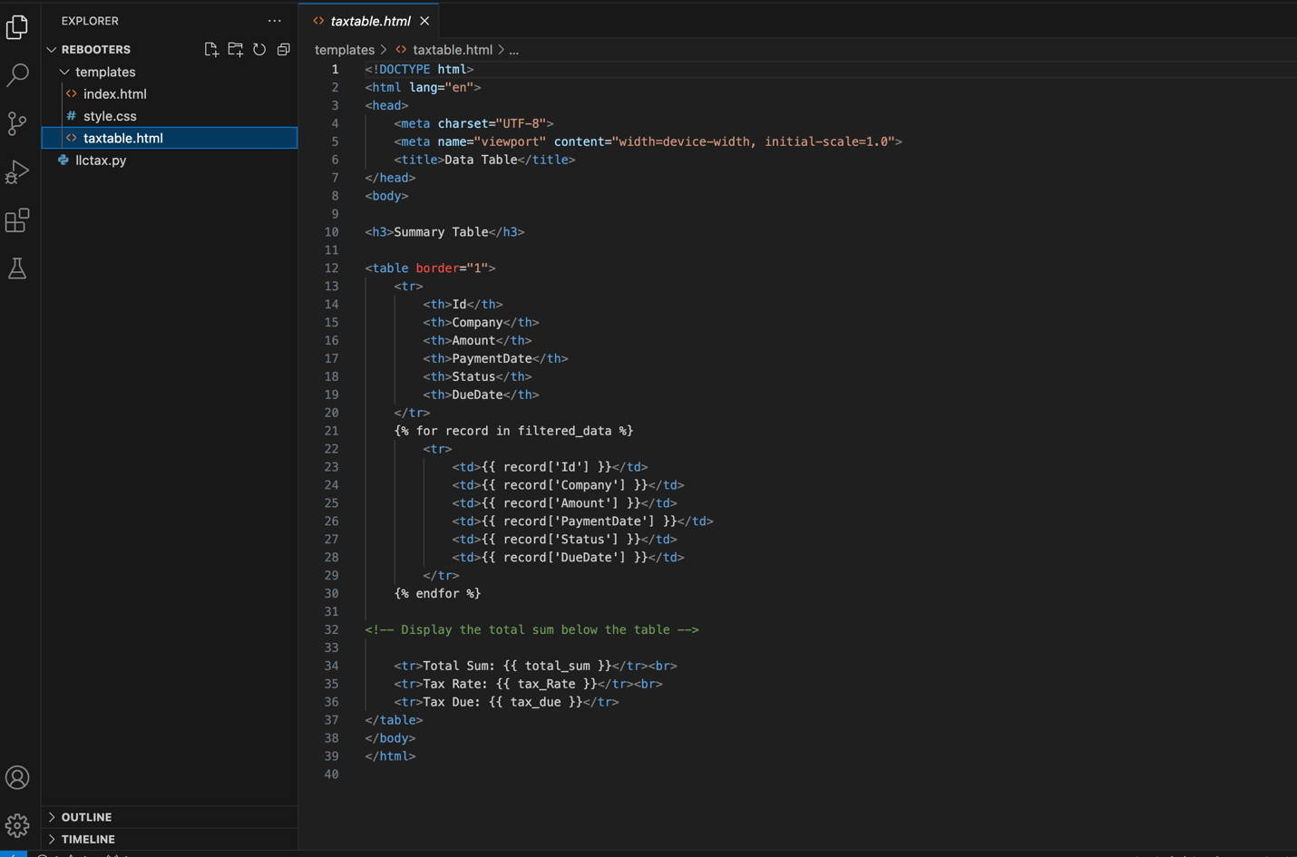

### CSS CODE

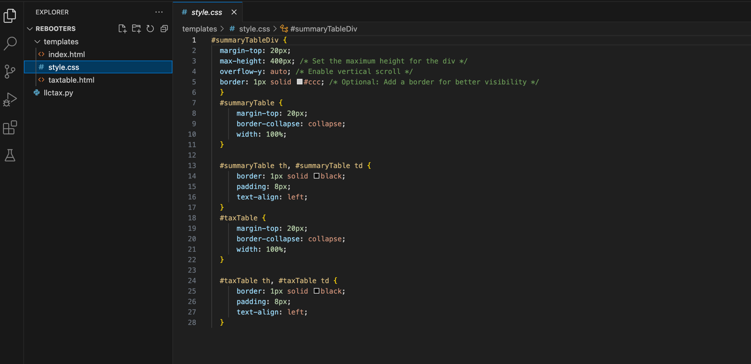

### SQL SCHEMA

We have created the database in MysqlWorkbench and the schema is as follows:

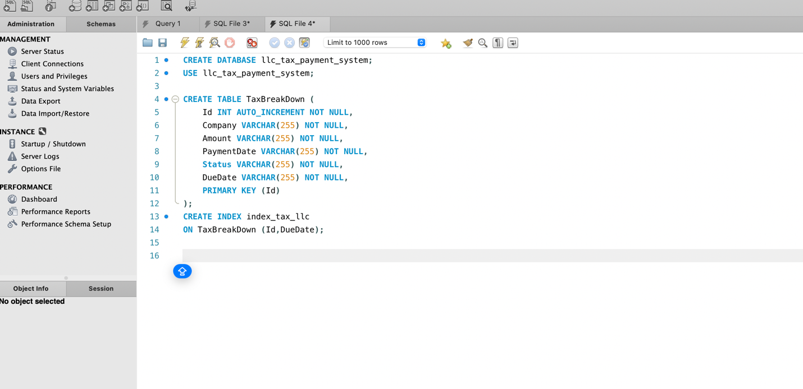

We have created an index “index_tax_llc” based on the columns “ID” and “DueDate” as we are retrieved data from and Database in instances where the rate of data retrieval improves. For instance, in case we select a DueDate from the dropdown and display the Summary tax table, the data retrieval is highly efficient.

# UI Interface

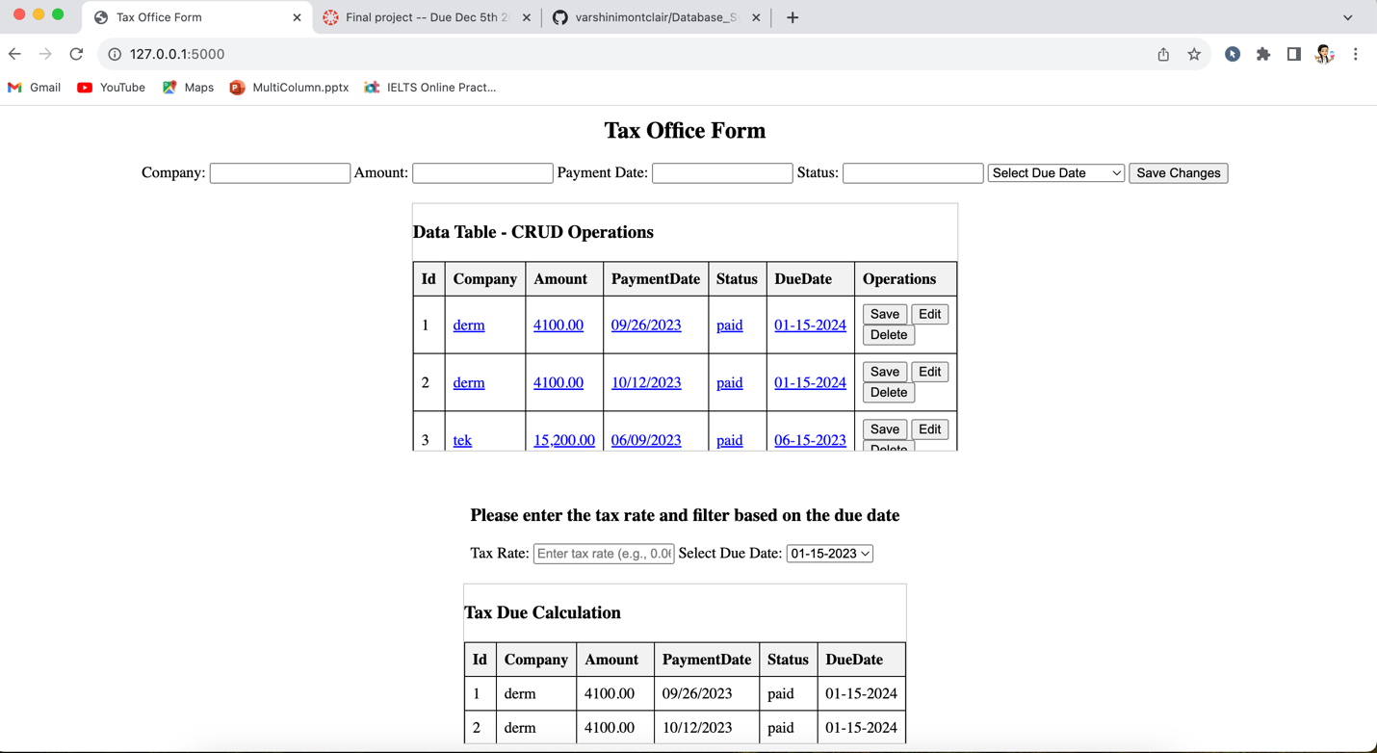

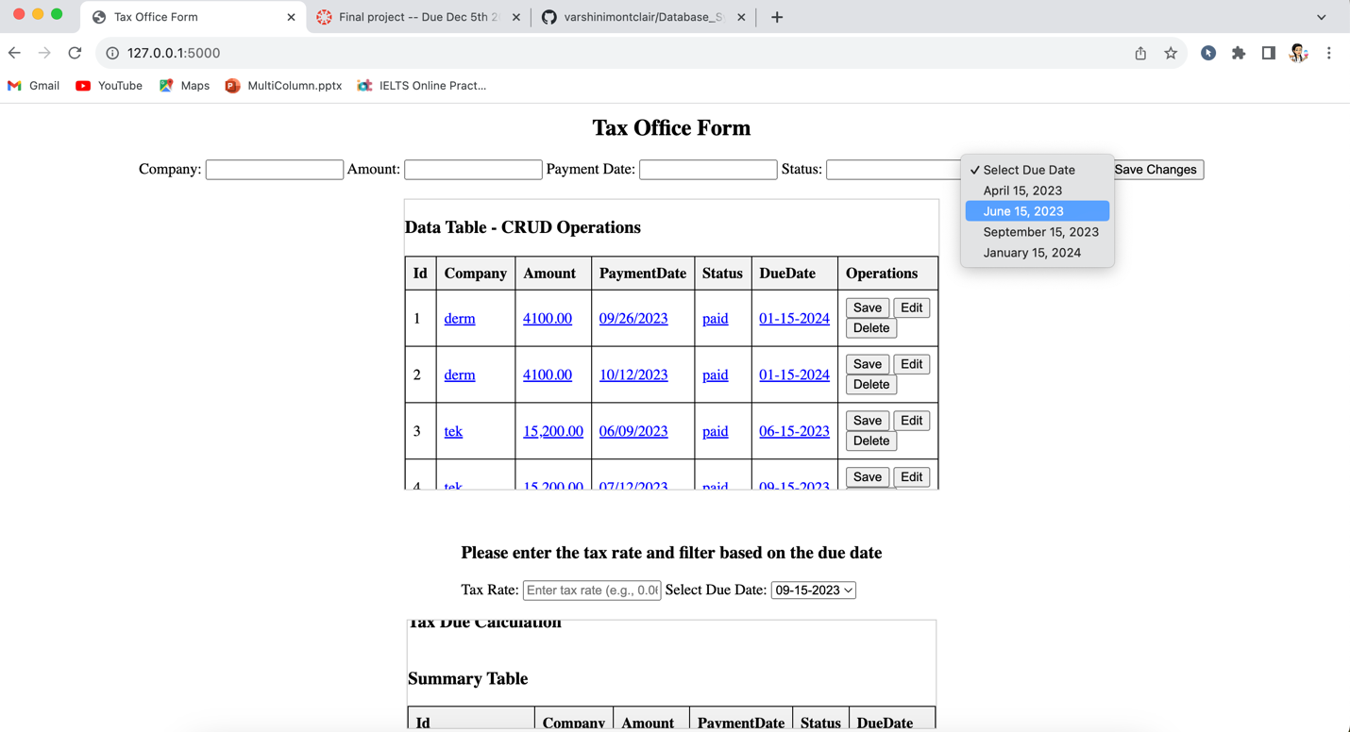

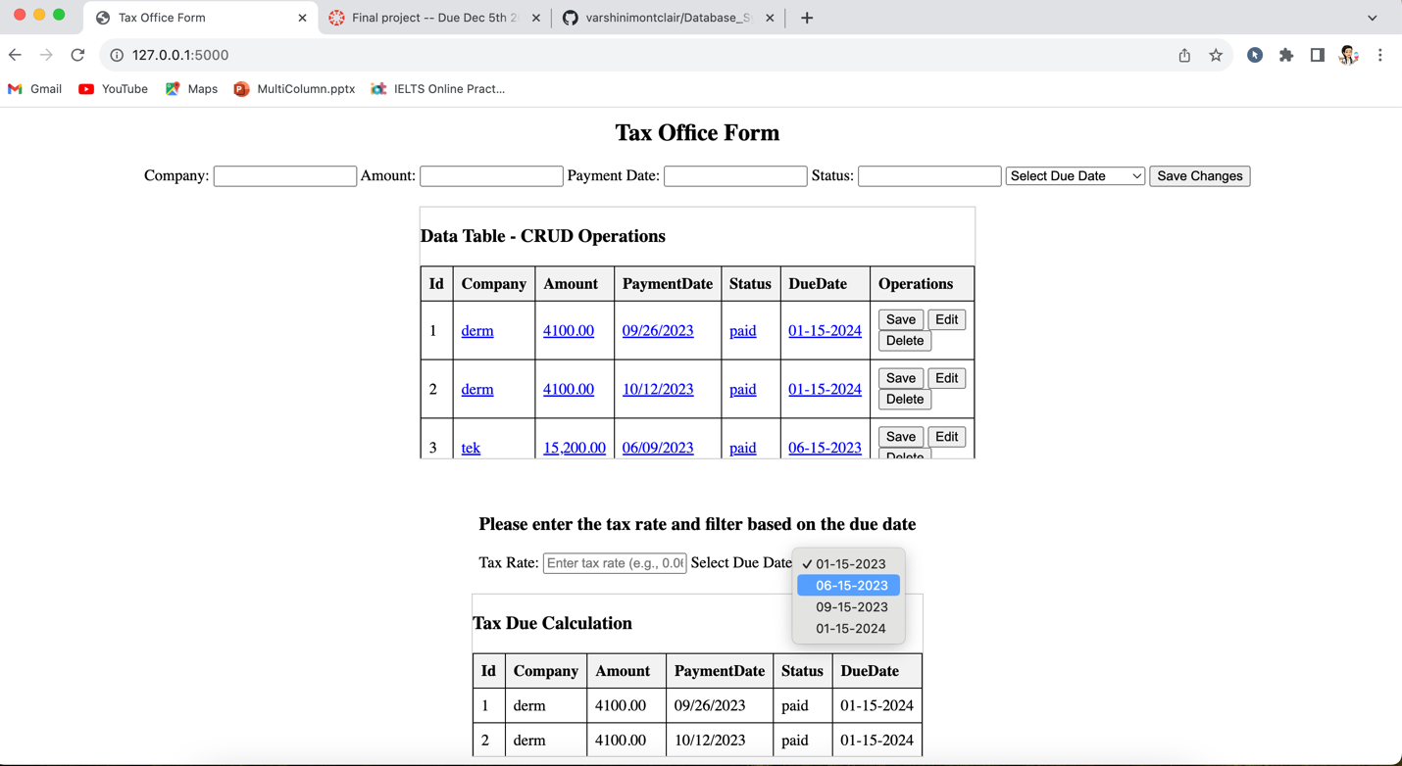

## USE CASE 1: CREATE

In this use case, the Tax office form page displays the attributes and text box for those attributes to enter the values to be inserted using an SQL insert statement in the flask route.

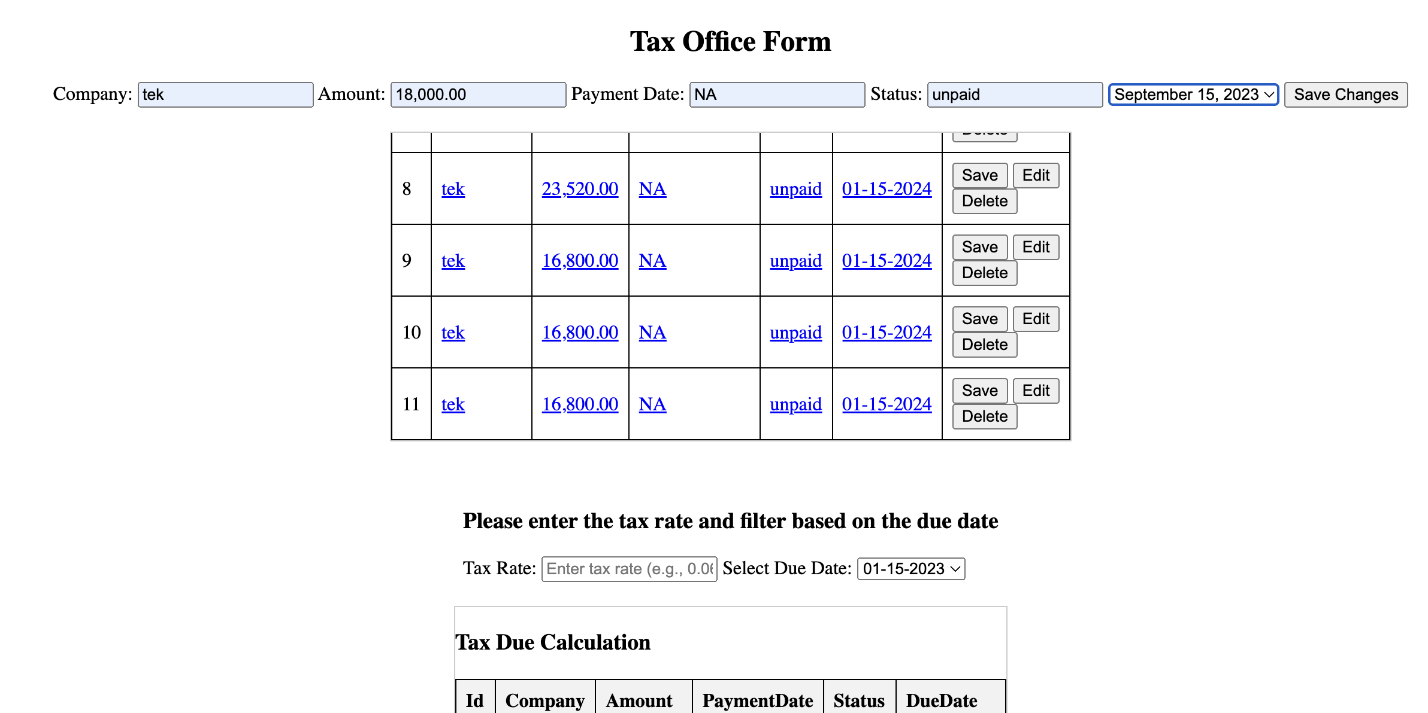

As soon as the user clicks the Save changes button, the values are inserted into the “TaxBreakDown” table.

## USE CASE 2: READ

In this use case all the data from the table “TaxBreakDown” is fetched and displayed in the form of a table along with the Operation column that has buttons for Saving, editing, and Deleting.

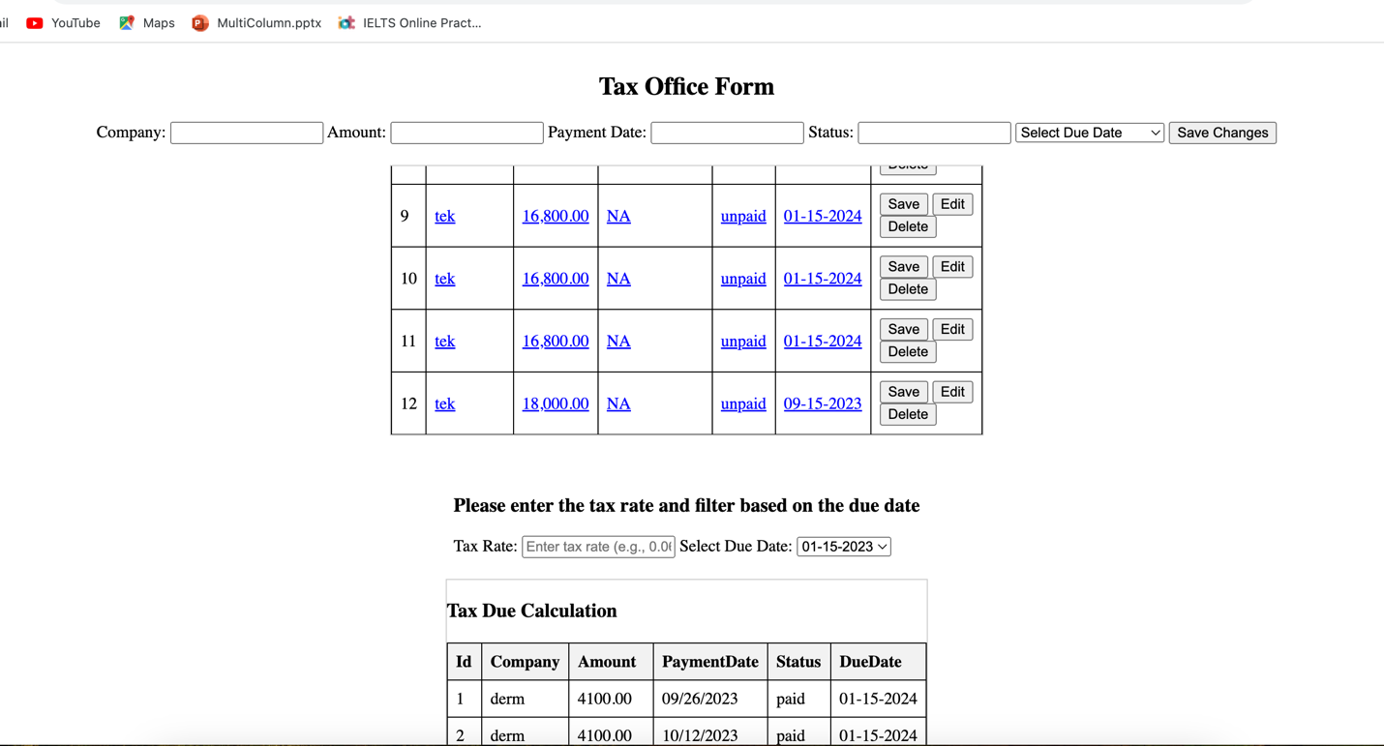

## USE Case 3: UPDATE

In this use case we have the option to edit or update the values and push them back to the database table “TaxBreakDown”. As soon as the user clicks the “Edit” button there will be a popup which asks the user to tap on any field that needs to be updated.

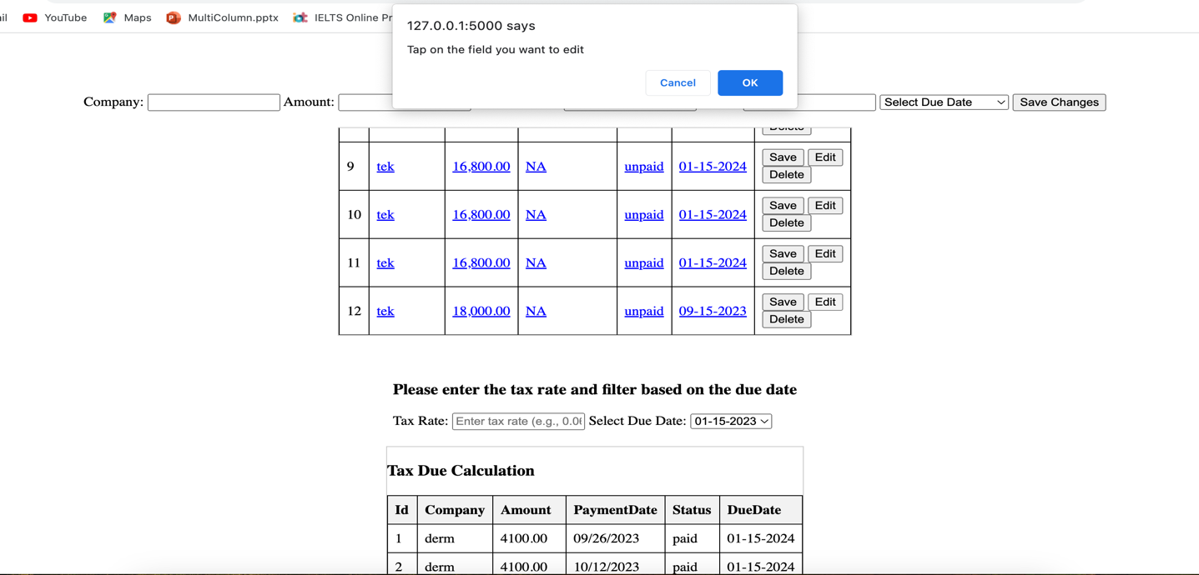

Here the user clicks on the “Amount” cell of the 12th row and updates it to “20,000.00”. Once the user updates that value and clicks on the Save button the new value gets updated in the table “TaxBreakDown” and the page automatically refreshes to display the latest data as shown in the second screenshot.

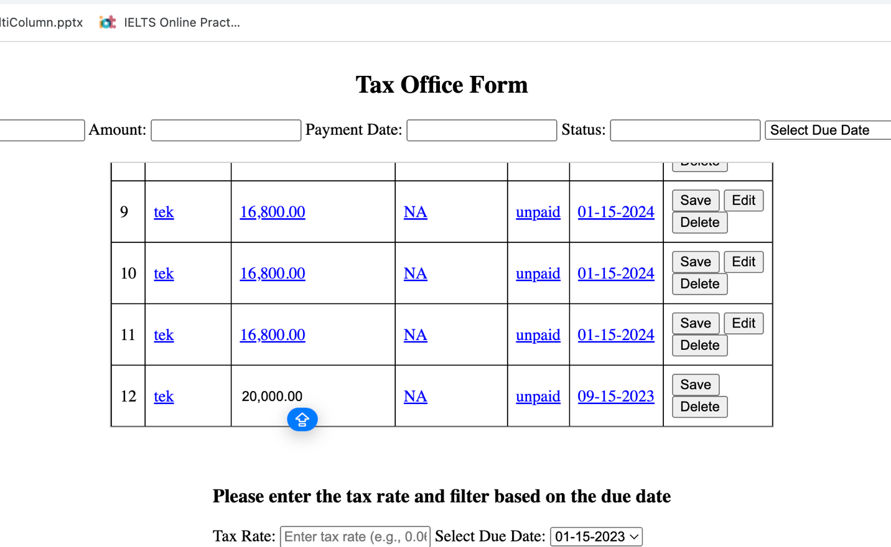

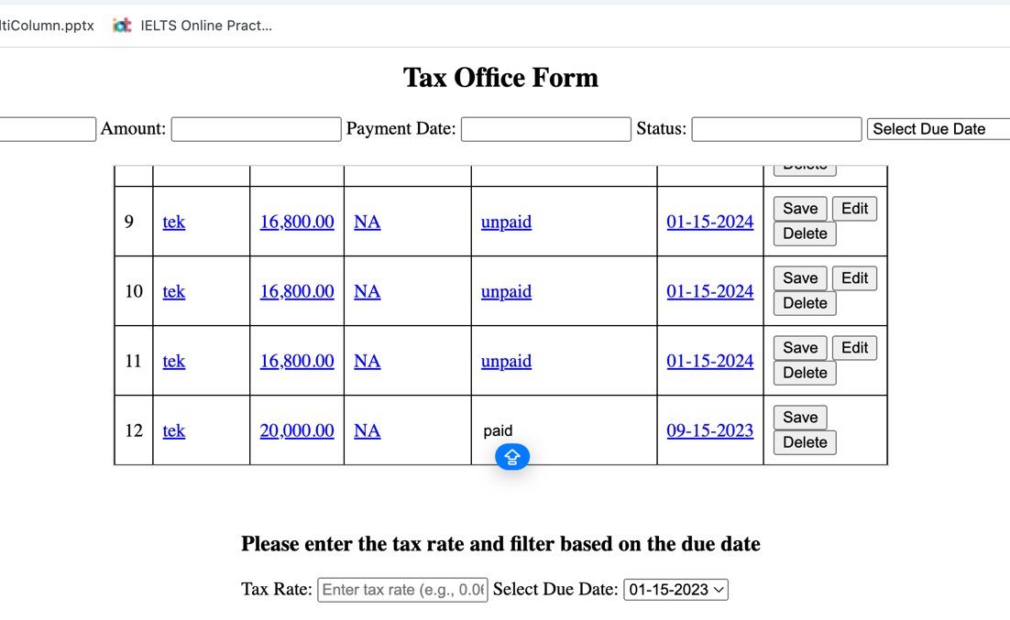

In the above screenshot, the value “20,000.00” is read from the database and displayed whereas the cell for the “Status” column of the 12th row is being updated.

## USE CASE 4: DELETE

In this use case, whenever a user clicks on “Delete” button a popup appears that alerts the user if they want to delete the record. As soon as the user clicks on “Ok” button the records get deleted as shown in the second screenshot. The records with ID “12” are now deleted and only 11 rows are displayed where the page gets automatically refreshed as soon as the “Ok” button is clicked.

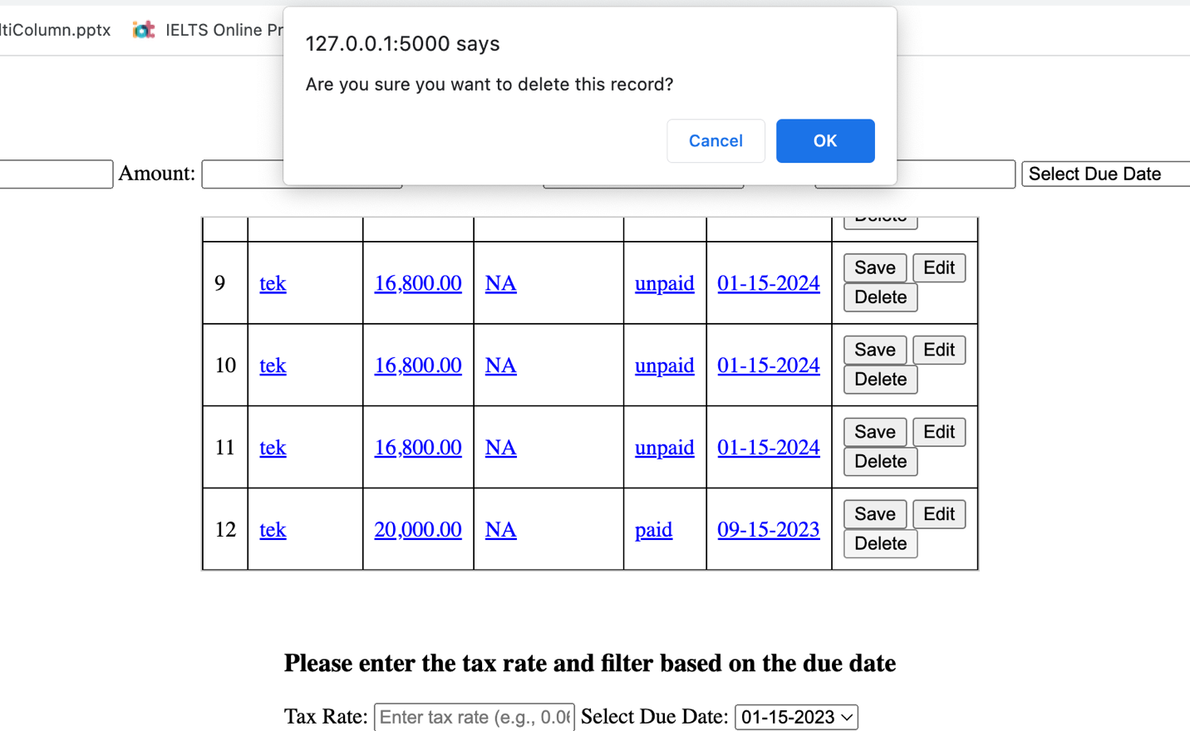

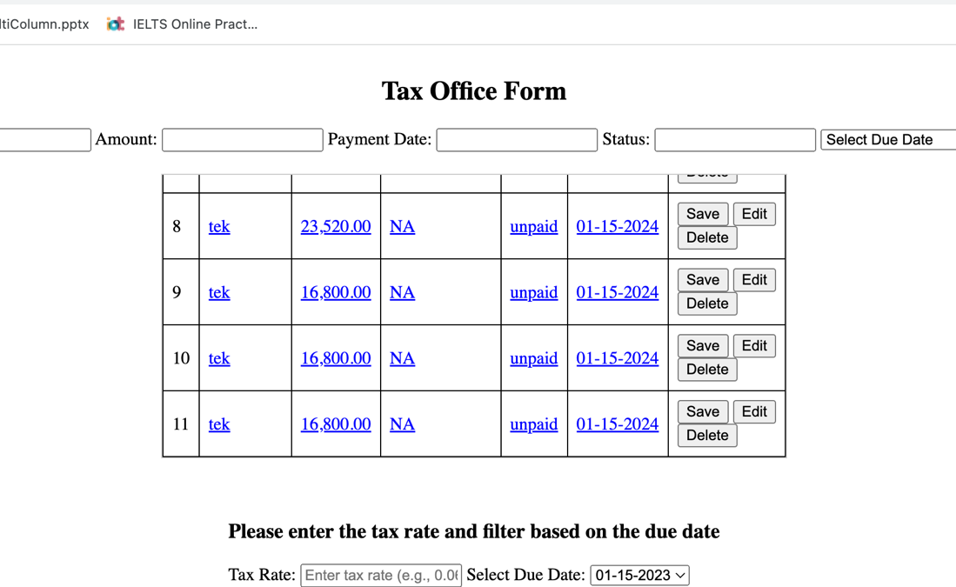

## USE CASE 5: TAX calculation

In this use case, when the user enters the tax rate and selects the due date, for example, entering a tax rate of '0.06' and selecting '06-15-2023', the tax due calculation table is automatically populated with the calculated tax amount based on the specified logic.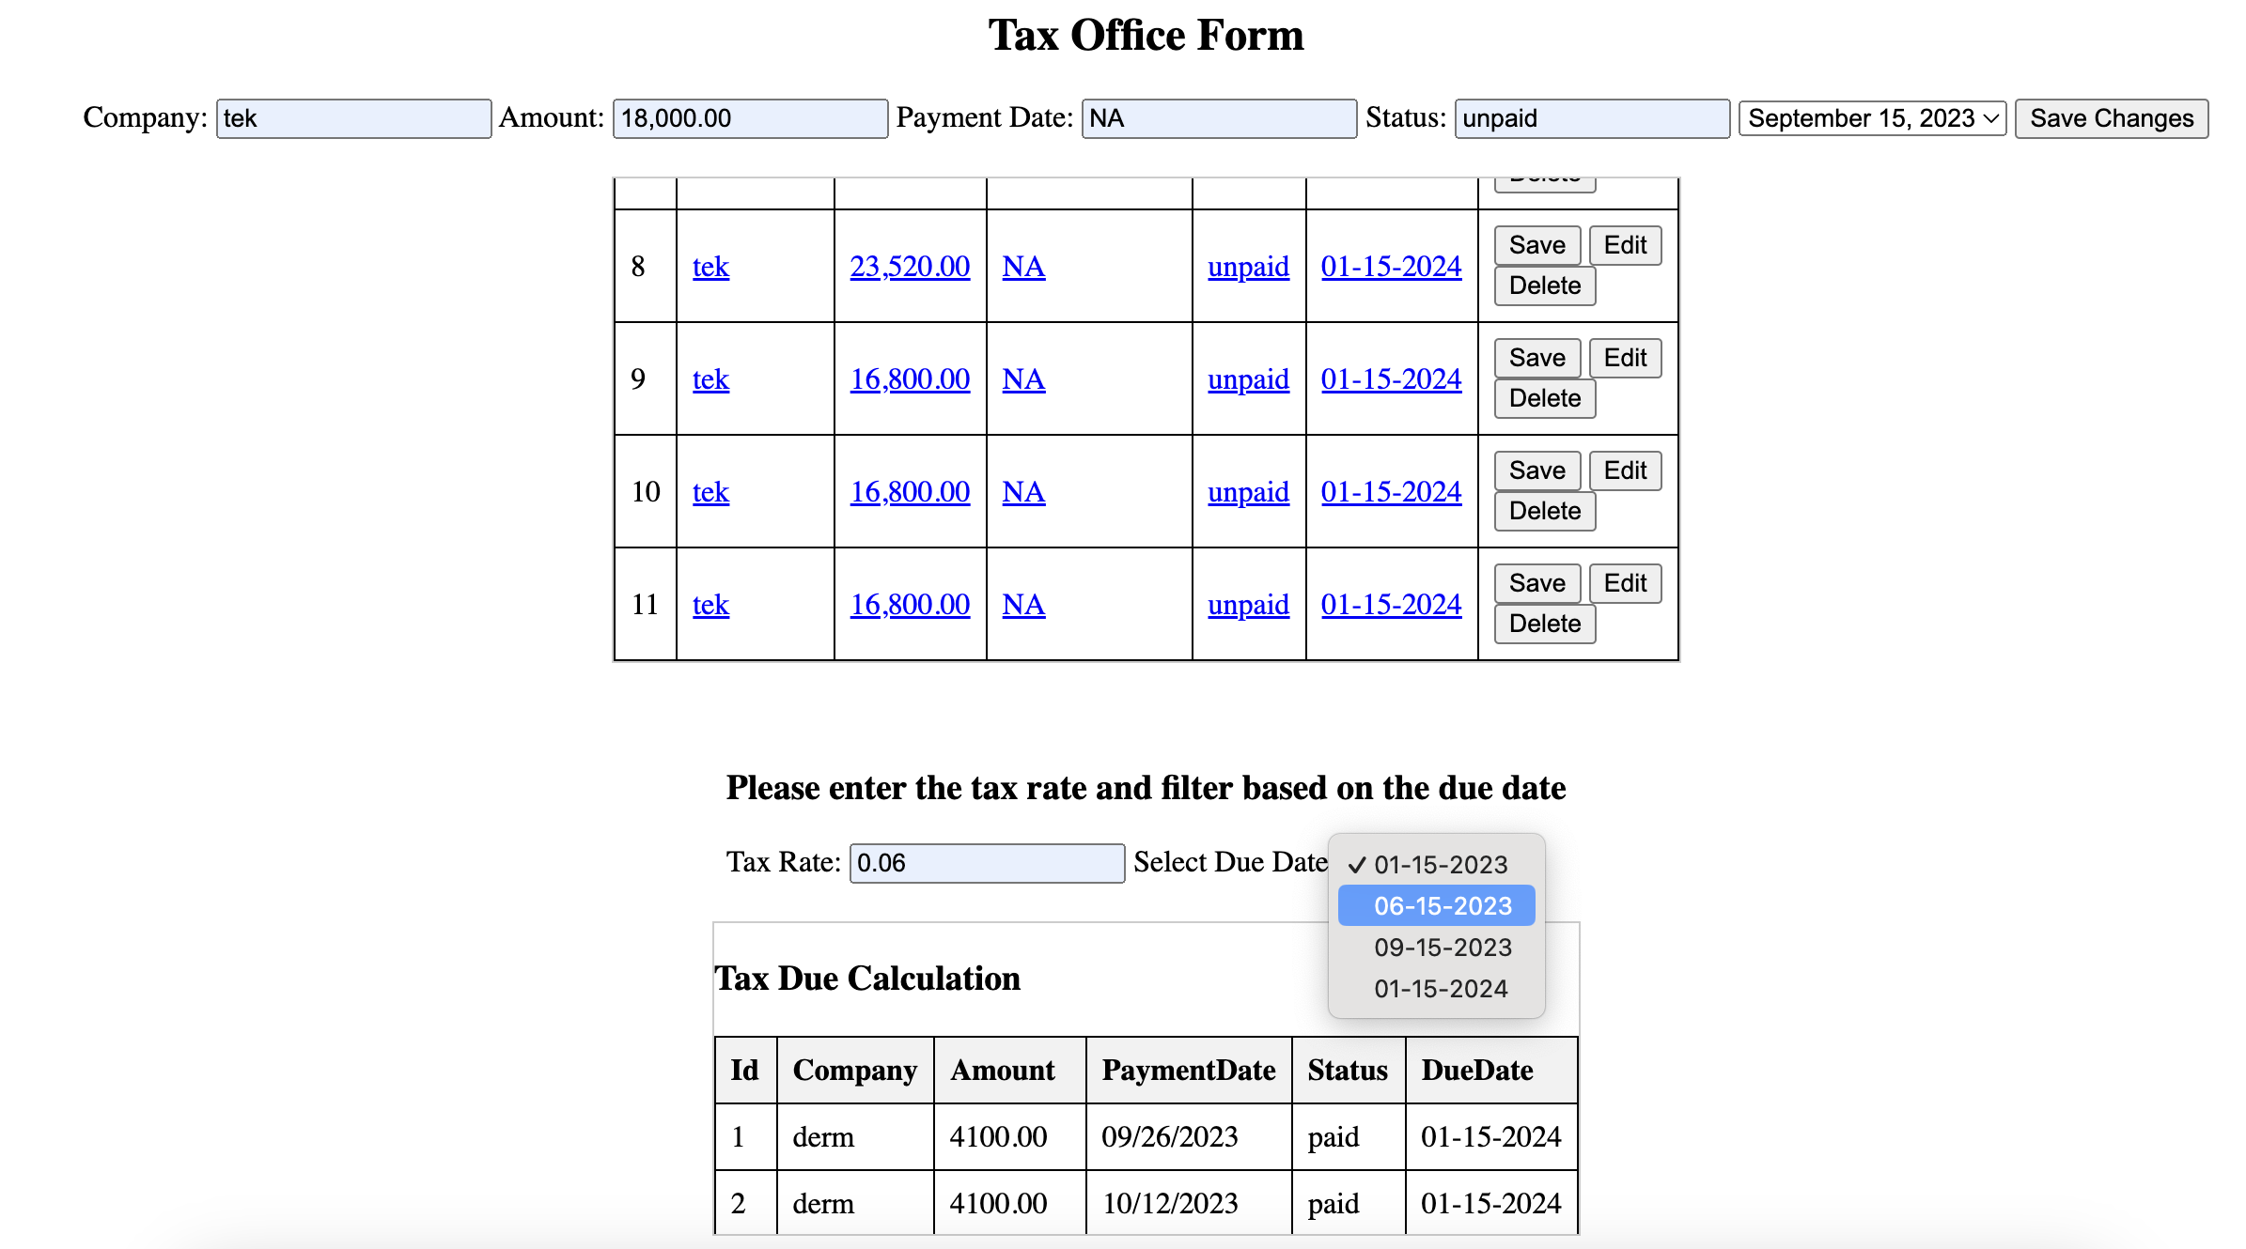

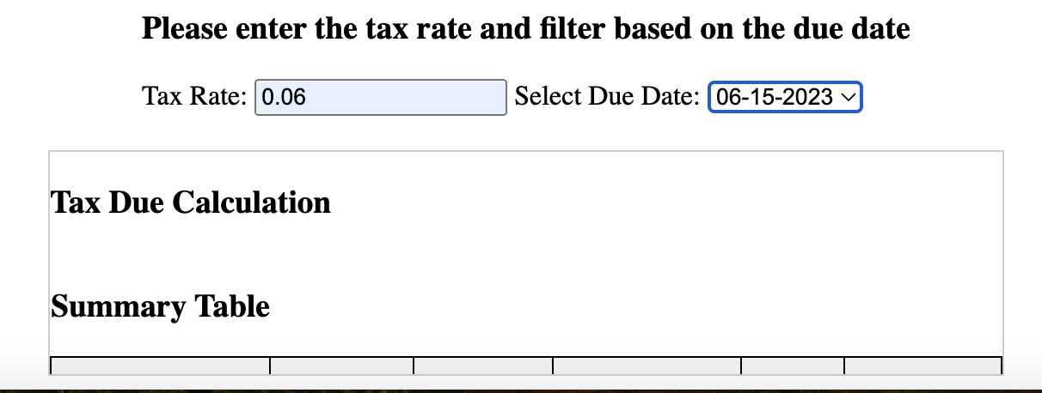

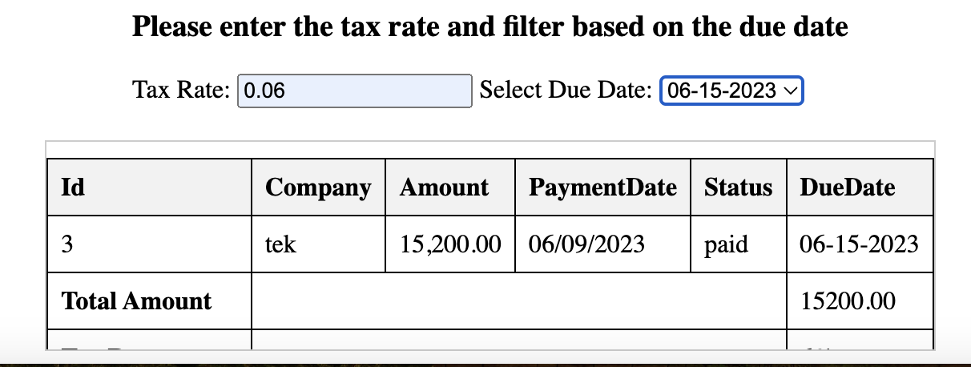

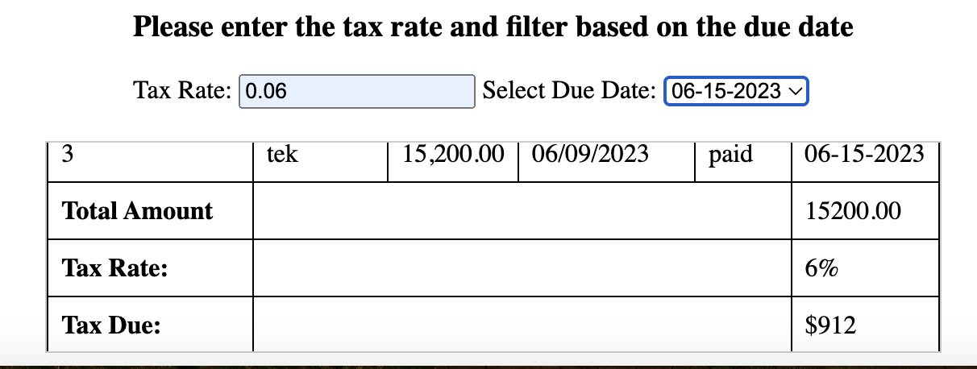

The above screenshots are specified in such a way that the scrollable div is depicted and the details are visible upon scrolling the Tax table.

# GitHub URL:

<https://github.com/varshinimontclair/Database_Systems.git>

YouTube URL:

<https://youtu.be/z8smnL4s2fc>